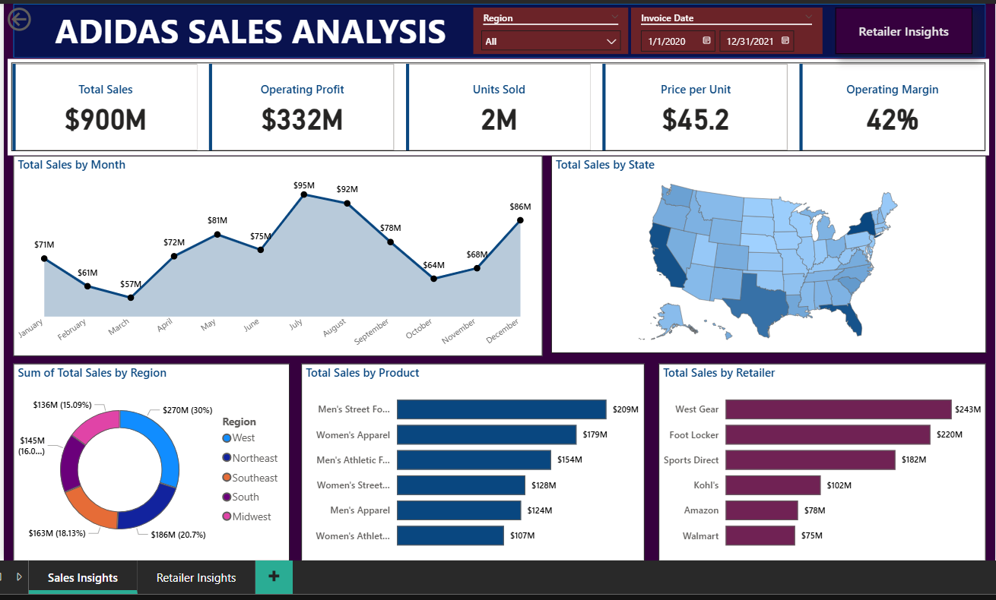

Key Insights of the dataset-

1) Total sales out of 2020 and 2021 is $900M.  
2) Profit generated from all the retailers out of this sale is $332M.  
3) Total units sold from all the stores is $2M.  
4) Price per unit- $45.2.  
5) Average margin is around 42%  
6) NY is highest selling followed by California, Florida and Texas.  
7) Highest sale is of Jul, Aug and Dec.  
8) Lowest sale is of Feb and Mar.

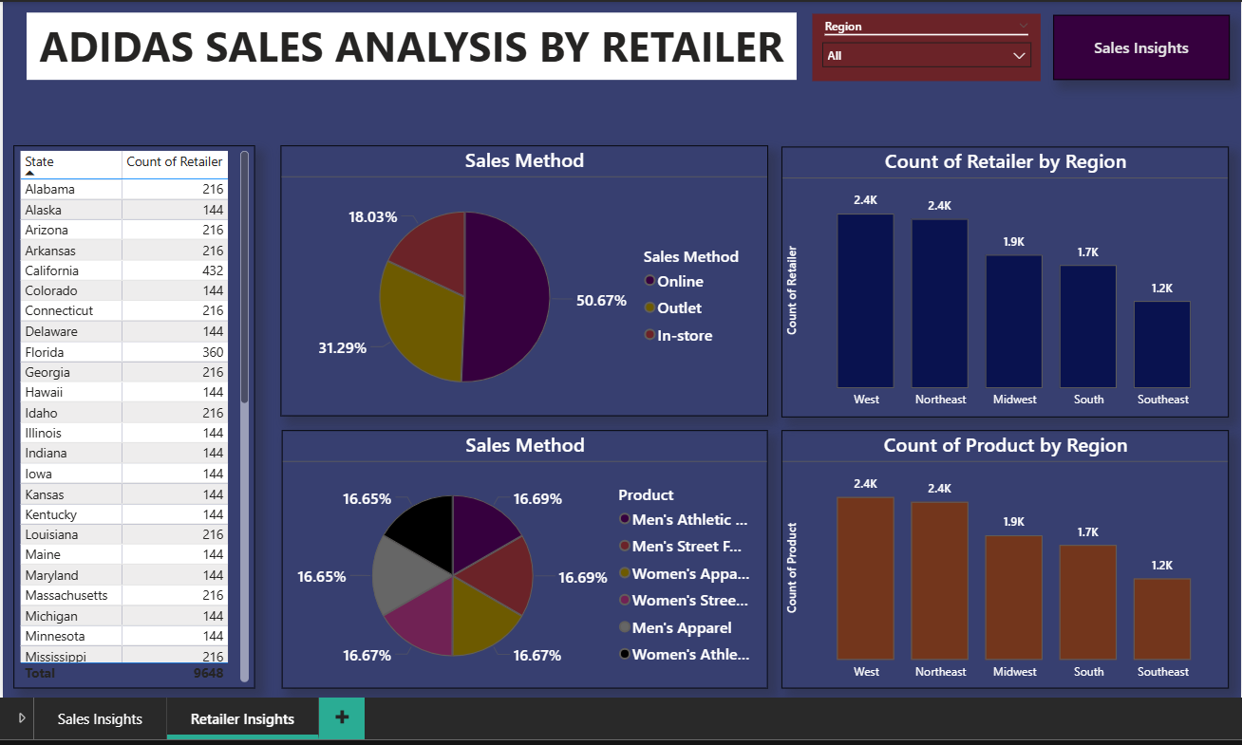

Key Insights of the dataset-

1) Sales was maximum with online orders followed by Outlets.  
2) Men's athletic footwear was the most sold product.  
3) West region has the highest count of retailers followed by Northeast region.  
4) West region has the highest count of products followed by Northeast region.  
5) Alabama has the highest count of retailers with 216 followed by Alaska.